Working to Learn

Career Preparation WEX 12

Learning to Work

Career Portfolio Project

Name:_______________________ Due Date:__________________

CAREER PREPARATION ONLINE PORTFOLIO PROJECT

The Importance of a Career Portfolio
A portfolio is a living and changing collection of records that reflects your accomplishments, skills, experiences and attributes. It can become a useful tool in marketing yourself to employers and post-secondary institutions. A portfolio does not replace a resume, but it can accentuate your abilities and what you can offer in the chosen field.
A portfolio is a multi-faceted way to organize your experiences, accomplishments, abilities and skills. It showcases your personality to potential employers and organizations and can help you prepare for an interview. It provides tangible proof of your skills and abilities and demonstrates to an employer that you are qualified for a specific job.

Career Cruising
Career Cruising is an excellent tool to help you build a Career Portfolio. We are using this online program because many Canadian post-secondary institutions are also using it in their career centers. The portfolio that you start to develop this year in Grade 12 can be maintained after high school as you will have continued access to it with all of your on-line devices.
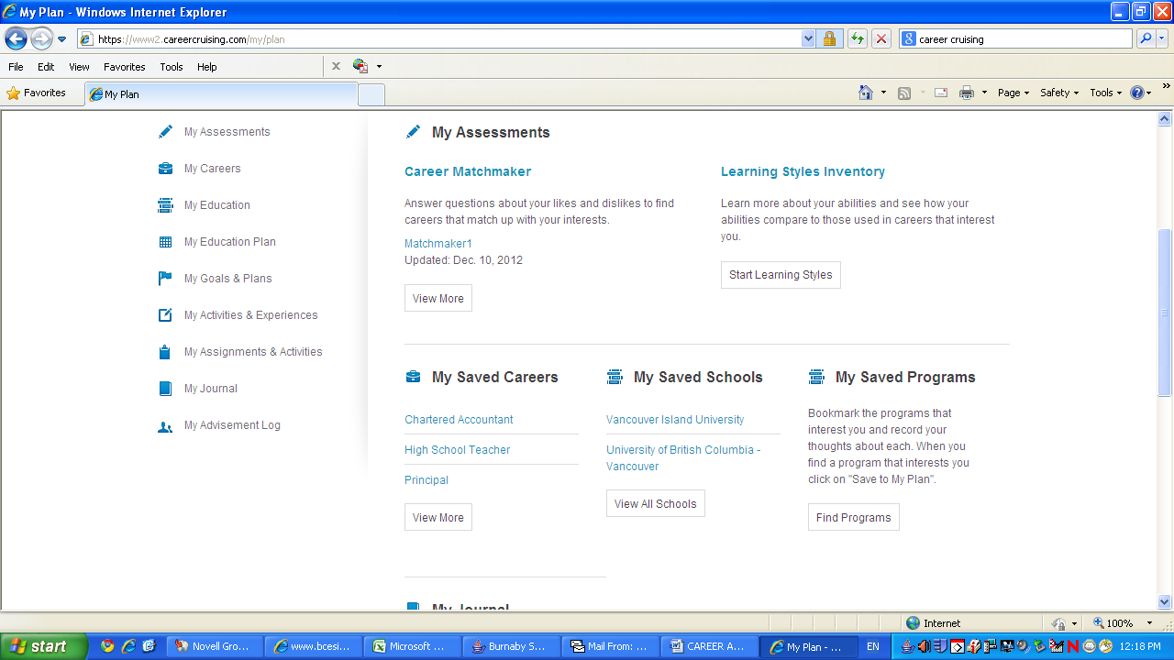
INSTRUCTIONS:
www.careercruising.com
Login:_____________
Password:__________
Follow the steps described below to build your online portfolio using www.careercruising.com

- CAREER SEARCH TOOLS
Go to: ASSESSMENTS:
  - Register – Create a username and password for MY PLAN, write down & store for future use
  - Complete the following:
- LEARNING STYLES INVENTORY
- MATCHMAKER & MY SKILLS
  - For Matchmaker-After 39 questions, click on “Answer more questions” to get a more accurate list of careers. Adjust the results by selecting appropriate levels of education you consider pursuing. Then, review the list of suggested careers, read about them and choose the two careers that most interest you and save them to MY PLAN.
  - Open MY PLAN, Select My Journal from the list on the left side of screen
- Add a new entry with the title: “My Strengths and Skills”
- Under this heading, list a minimum of three strengths and skills that you possess. Do three for each career you saved and explain why they will make you a good fit. Scroll to the bottom of the screen and press save. (Quick example of skills: leadership, communication, team work. Refer to the Orientation Booklet for additional suggestions.)

- BUILD YOUR PORTFOLIO OF EXPERIENCES
- Open Career Cruising, Open MY ACCOUNT, select Profile and enter your personal information: Name, Address (with Postal Code), Phone Number & Email
- Select MY ACTIVITES AND EXPERIENCES and enter:
- extracurricular activities
- hobbies, interests, skills and abilities
- awards & certificates
- any volunteer experience
- your work experience
Activities should have an organization name, position title, and brief description of duties. (Example: Sport Chek, Sales Associate Work Experience Student
July 21, 2014-July 28, 2014
-Organized and tagged inventory, kept store tidy, directed customers to appropriate departments)
- Select MY PLAN homepage, scroll to the bottom right of the screen
- upload and save copies of all your Work Experience evaluations and any of your certificates to MY FILES. Be sure that they are named & dated appropriately before you upload them (Example: “Sport Chek, Oct 2012 Evaluation”). Each document should be uploaded separately (do not upload 2 work experience documents in one file).
- JOB SEARCH
Choose one of the two careers you saved to your plan above in Part 1. (If none of the careers suggested by Career Cruising interest you, manually search a career by clicking on the Careers tab at the top of the page, typing the name of the career you want to search, or typing a keyword, e.g. “retail salesperson”).
Then, follow these instructions:
- Click on the job title
- Click on the Find Jobs button located on the left-hand side, inside the Job Search box
- Type “Vancouver” in the Location box and click on the Find Jobs button (If no jobs come up, go back to the previous screen and select another related career option, or nearest job match possible, from the drop-down menu beside your original career choice, and try again).
- Print the one job that is most interesting to you. Attach the posting to your project.
- Repeat steps a. – d. to try to find an entry level job that you could potentially apply to now (no post-secondary needed). Areas like retail, junior office, restaurant, parks & recreation leaders, coaching, etc. would be good places to start looking.

- JOB PROSPECTS AND EMPLOYMENT OUTLOOK
- Go to: www.workbc.ca
- Go to the Explore Careers & Industries drop-down menu and click on Career Profiles
- Click on the Index Tab and type the future career into the search field (you may need to try different career titles, or use the Browse Profiles function to help)
- Click on Employment Outlook and Career Paths; read and learn about the expected future demand, statistics and employment outlook for this type of career

- Go back into Career Cruising
- Open MY PLAN, Select My Journal from the list on the left side of screen
- Add a new entry with the title: “Job Prospects – Future Demand”
- In 2-3 sentences, summarize the future job prospects for this career based on the information you read on WorkBC.ca

- JOB APPLICATION TOOLS: Resume, Cover Letter and Interview Preparation
  - Job-Specific Resume:
- Prepare and print a job-specific resume for the entry level job posting that you printed from the job search (3 e.). The resume must include an objective that describes the position you are applying for and must also list your relevant skills
- In Career Cruising, Open MY PLAN, scroll to the bottom right of the screen
- Upload and save your resume to MY FILES (File name should be “Your Name’s Resume, month, year”)
- OR
- If you need help creating a resume, you can get tips from the Orientation Booklet and/or use Career Cruising:
- In Career Cruising, select the “Employment” tab across the bar at the top
- Select “Build my Resume”
- Be sure to download the final resume to a word document and fix any formatting errors before uploading it

  - Job-Specific Cover Letter:
- Prepare and print a job-specific cover letter that supports your resume for the entry-level job printed in Part 3 e. Upload and save the finished cover letter to MY FILES section in Career Cruising (File name should be “Your Name’s Cover Letter, month, year”):
OR
- If you need help, you can get tips from the Orientation Booklet and/or use Career Cruising.
- In Career Cruising, select the “Employment” tab across the bar at the top
- Select “Letter Writing” on the left side and explore

  - Interview Preparation:
Prepare answers to the following three typical interview questions. Type both the questions and your answers in a Word Document, then print and attach. (See the Interview Section in the Orientation Booklet for additional information about interview preparation.)

    - Why do you feel you are a good candidate for this job? (focus on the skills you can contribute; refer to the Orientation Booklet for ideas)
    - What five words best describe you? (support these with examples)
  - Describe a difficult school or work situation and how you handled it.

- WORK EXPERIENCE REFLECTION AND SUMMARY
  - Open Career Cruising, Open MY PLAN, Select My Journal from the list on the left
- Add a new entry with the title: “My Career Preparation Work Experiences”. Answer in complete sentences/small paragraphs. Print and attach to project.
- What did you learn from your work experience, either positive or negative, that confirmed or changed your future career interests and/or choices?
- How did your Career Preparation experience help you with your future plans, such as planning for post-secondary programs or further training, looking for a job, or learning new skills?
- What suggestions/advice would you give to a student entering WEX 12A.
  - Still in My Journal, create a new entry with the title “My Guaranteed Rights in The Workplace.” (use two journal entries if you need more space)
- Congratulations—you have landed a job! Now it’s important for you to review the basic employee rights that are guaranteed by the BC Government. Refer to the sections in the Orientation Booklet called “Employment Standards Act” and “Human Rights Act” and answer the following questions.
Please type both the questions and answers. Write in complete sentences:

- How does an employee qualify for statutory holiday pay?
- Does an employer have to provide a coffee break in an 8-hour period?
- Explain the two different rates of overtime pay.
- How is vacation pay calculated?

- PRINT YOUR ASSIGNMENT
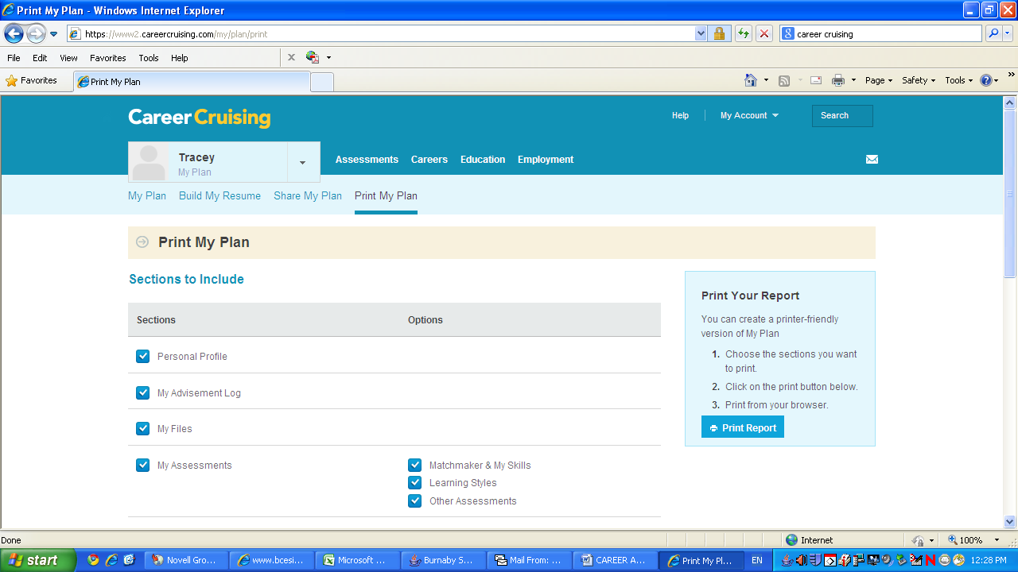 Open Career Cruising, Open MY PLAN, select PRINT MY PLAN from the top menu.

a. Select and print the following only:
Personal Profile
My Files
My Assessments
My Careers
My Activities and Experiences
My Journal: choose option All Entries

b. Also print:
- Career job posting, entry-level job posting, your resume, cover letter, and interview questions and answers

c. Collate and staple in this order: a simple title page (your name and “Career Portfolio
Project”), MY PLAN, Job Searches, Resume, Cover letter, Interview questions and answers,

