Calling all Volunteers

Rideau Manor is looking for compassionate caring young adults to build relationships with residents

We have opportunities for all days of the week, helping with all kinds of programs. If you have an interest in volunteering with seniors please fill out an application form and drop it off to Rideau Manor today!

Must be 15 years or older
Must complete a criminal record check
Must commit to 3 months of services

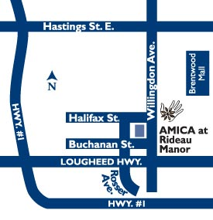
For further information, contact
Ali Vrzal - Wellness and Vitality Supervisor
604.291.1792
a.vrzal@amica.ca

